

**Assignment Report of Computer Graphics Lab**

Course title: Computer Graphics Lab

Course code: CSE422

Submitted by,

Name: Rashidul Hasan Hridoy

ID: 171-15-8596

Section: O3

Department of Computer Science & Engineering,

Daffodil International University

Submitted to,

[S](https://sites.google.com/view/syedatanjilaatik)yeda Tanjila Atik

Lecturer

Department of Computer Science and Engineering,

Daffodil International University

Date of submission: 29-06-20

**Graph**

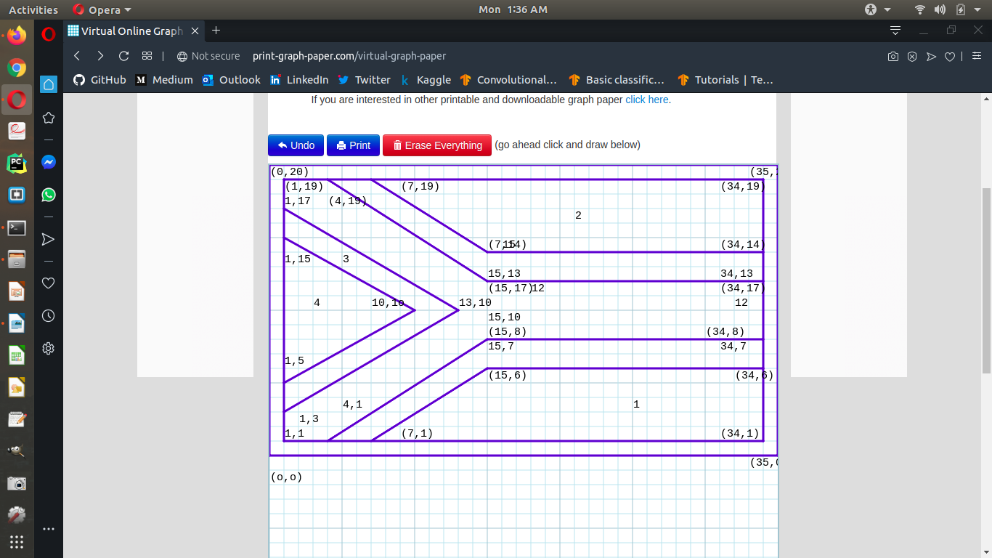

After first try I adjust some points again, but can’t remove these from graph. I’m sorry for that.

**Code**

#include <GL/glut.h>

void init(void)

{

// Set display window colour to white

glClearColor(0.0, 0.0, 0.0, 0.0);

// Set projection parameters

glMatrixMode(GL_PROJECTION);

gluOrtho2D(0.0, 35.0, 0.0, 20.0);

}

void drawShapes(void)

{

// Clear display window

glClear(GL_COLOR_BUFFER_BIT);

//main_box

glColor3f(1.0, 1.0, 1.0);

glBegin(GL_POLYGON);

glVertex2i(0, 20);

glVertex2i(35, 20);

glVertex2i(0, 20);

glVertex2i(0, 0);

glVertex2i(0, 0);

glVertex2i(35, 0);

glVertex2i(35, 0);

glVertex2i(35, 20);

glEnd();

//1

glColor3f(0.0, 0.0, 1.0);

glBegin(GL_POLYGON);

glVertex2i(15,6);

glVertex2i(34,6);

glVertex2i(15,6);

glVertex2i(7,1);

glVertex2i(7,1);

glVertex2i(34,1);

glVertex2i(34,1);

glVertex2i(34,6);

glEnd();

//2

glColor3f(1.0, 0.0, 0.0);

glBegin(GL_POLYGON);

glVertex2i(7,19);

glVertex2i(34,19);

glVertex2i(7,19);

glVertex2i(15,14);

glVertex2i(15,14);

glVertex2i(34,14);

glVertex2i(34,14);

glVertex2i(34,19);

glEnd();

//3

glColor3f(255.0, 215.0, 0.0);

glBegin(GL_POLYGON);

glVertex2i(1,17);

glVertex2i(13,10);

glVertex2i(13,10);

glVertex2i(1,3);

glVertex2i(1,3);

glVertex2i(1,17);

glEnd();

//4

glColor3f(0.0, 0.0, 0.0);

glBegin(GL_POLYGON);

glVertex2i(1,15);

glVertex2i(10,10);

glVertex2i(10,10);

glVertex2i(1,5);

glVertex2i(1,5);

glVertex2i(1,15);

glEnd();

//5

glColor3f(0.0, 0.5, 0.0);

glBegin(GL_POLYGON);

glVertex2i(15,13);

glVertex2i(34,13);

glVertex2i(34,13);

glVertex2i(34,7);

glVertex2i(34,7);

glVertex2i(15,7);

glVertex2i(15,7);

glVertex2i(15,13);

glEnd();

//6

glColor3f(0.0, 0.5, 0.0);

glBegin(GL_POLYGON);

glVertex2i(13, 10);

glVertex2i(15, 10);

glVertex2i(15,10);

glVertex2i(15,8);

glVertex2i(15,7);

glVertex2i(5,1);

glVertex2i(5,1);

glVertex2i(1,1);

glVertex2i(1,1);

glVertex2i(1,3);

glVertex2i(1,3);

glVertex2i(13,10);

glEnd();

//7

glColor3f(0,0.5,0);

glBegin(GL_POLYGON);

glVertex2i(1,19);

glVertex2i(5,19);

glVertex2i(5,19);

glVertex2i(15,13);

glVertex2i(15,13);

glVertex2i(15,10);

glVertex2i(15,10);

glVertex2i(13,10);

glVertex2i(13,10);

glVertex2i(1,17);

glVertex2i(1,17);

glVertex2i(1,19);

glEnd();

glFlush();

// Process all OpenGL routines

}

int main(int argc, char* argv[])

{

glutInit(&argc, argv); // Initalise GLUT

glutInitDisplayMode(GLUT_SINGLE|GLUT_RGB); // Set display mode

glutInitWindowPosition(100, 100); // Set window position

glutInitWindowSize(700, 600); // Set window size

glutCreateWindow("171-15-8596"); // Create display window

init(); // Execute initialisation procedure

glutDisplayFunc(drawShapes); // Send graphics to display window

glutMainLoop(); // Display everything and wait

return 0;

}

**Screenshot of the output**

